PARK IMPACT FEE CREDIT AGREEMENT BY AND BETWEEN THE TOWN OF WHITESTOWN
AND BRAUN PROPERTY DEVELOPMENT, LLC

THIS PARK IMPACT FEE AGREEMENT ("Agreement") is made and entered into this ___day of, ____________, 2023, by and between the TOWN OF WHITESTOWN, Boone County, Indiana, an Indiana municipal corporation (“Town”), and BRAUN PROPERTY DEVELOPMENT, LLC (“Builder”), as follows:

WHEREAS, pursuant to Ind. Code § 36-7-4 et. seq., the Town adopted an ordinance establishing park and recreation impact fees that are assessed for new development;

WHEREAS, the Town desires to foster the development and improvement of its parks and parks infrastructure through cooperative efforts with the development community;

WHEREAS, Builder desires to assist the Town in its effort to improve the Town’s parks system and infrastructure;

WHEREAS, Builder is the owner and/or developer of property depicted and described in Exhibit A, attached hereto and incorporated herein by reference (the “Real Estate”);

WHEREAS, Builder is developing residential communities, known as Jackson Run and Jackson Run North, with a total buildout of approximately 296 single family residential homes, inclusive of 146 homes in Jackson Run and 150 homes in Jackson Run North (collectively, the “Communities”), on the Real Estate;

WHEREAS, the Communities may be built in phases, each of which is subject to park impact fees of the Town; and

WHEREAS, Builder desires to convey to the Town and the Town desires to accept a portion of the Real Estate to assist the Town in improving the Town’s parks system and infrastructure (the “Park Land”) as depicted and described on the attached Exhibit B, which is incorporated herein by reference; and

WHEREAS, pursuant to Ind. Code § 36-7-4-1335, in consideration for Builder causing the Park Land to be conveyed to the Town as shown on Exhibit A (the “Builder Commitment”), the Town desires to issue Builder a park impact fee (“PIF”) credit in an amount equal to the fair market value of the Park Land, and

WHEREAS, the Town and Builder further desire to provide for a one-time payment to Builder at the time of transfer of the Park Land, to the extent the fair market value of the Park Land exceeds the PIF credits provided hereunder may be used within the Communities.

NOW, THEREFORE, in consideration of the foregoing and of the mutual covenants and agreements herein contained, and other good and valuable consideration, the receipt and sufficiency of which are hereby acknowledged, the parties do hereby agree as follows:

ARTICLE I. INCORPORATION OF RECITALS

The representations, covenants and recitations set forth in the foregoing recitals are material to this Agreement and are hereby incorporated into and made a part of this Agreement as if fully set forth in this Article I.

ARTICLE II. COMMITMENTS

2.01. Builder’s Commitment. In consideration for the Town issuing PIF credits as set forth below Builder hereby agrees to satisfy the Builder Commitment. As a part of the Builder Commitment, the Park Land and any improvements therefore shall be conveyed to the Town by General Warranty Deed in fee simple in a form reasonably required by the Town, free and clear of all liens and encumbrances not reasonably acceptable to the Town, and with a standard owner’s policy of title insurance issued by a title company reasonably acceptable to the Town, in which the title insurer agrees to insure, in the full amount of the PIF Credits plus the Net Payment (as hereinafter defined), merchantability title to the Property in the name of the Town, all at Builder’s sole cost and expense. In addition, any improvements and related costs to the Park Land by Developer for which PIF credits may be granted shall be submitted to the Town for review and approval prior to such expenditure.

Prior to the transfer of the Park Land to the Town, the Builder shall provide an adequate opportunity for the Town to conduct environmental surveys, review title work, and obtain other feasibility studies related to the Town’s proposed use of the Park Land at the Town’s own cost and expense, and the Town shall have the right to satisfy itself relative to drainage, permits, environmental conditions, access, and any other matters relevant to the Town’s proposed use of the Park Land as park and recreation property (“Contingencies”). In the event that the Town determines that it is not satisfied as to any Contingencies prior to the Town’s acceptance of the Park Land, the Town may terminate this Agreement and the parties shall have no further rights or obligations under this Agreement. In addition, the Town may terminate this Agreement if the Builder fails to transfer the Park Land to the Town as set forth herein within one (1) year of execution of the Agreement. In the event the Park Land is not transferred to and accepted by the Town for any reason, the Builder will immediately pay to the Town upon demand any PIFs applicable to the Communities that had not been collected by the Town.

2.02 Town’s Commitments. Upon the Town’s acceptance of the transfer of the Park Land to the Town, the Town will issue Builder the PIF Credits in the amount of $447,256 (“PIF Credits”), and will further pay to the Builder at the closing of the Park Land transfer the amount of $57,412 (“Net Payment”), which represents the difference between the Town’s total compensation for the Park Land and PIF Credits. The PIF Credits, once issued by the Town, may be applied by the Builder against the PIFs that are or may be owed to the Town by the Builder for new residential units in the Communities.

This Agreement shall not provide any PIF Credits for the Builder concerning any other development. Accordingly, the PIF Credits authorized in this Agreement may be applied by Builder only to those park impact fees that may be imposed on new residential units within the Communities. The Builder shall pay any additional PIFs to the Town if the amount of PIF’s owed for the Community exceed the total available PIF Credits. Moreover, notwithstanding anything to the contrary, all PIF Credits not used for new residential units within the Communities within ten (10) years of execution of this Agreement shall expire and will no longer be available for use against PIFs.

ARTICLE III. GENERAL PROVISIONS

3.01 Time of Essence. Time is of the essence of this Agreement. The parties shall make every reasonable effort to expedite the subject matters hereof (subject to any time limitations described herein) and acknowledge that the successful performance of this Agreement requires their continued cooperation.

3.02 Breach. Before any failure of any party of this Agreement to perform its obligations under this Agreement shall be deemed to be a breach of this Agreement, the party claiming such failure shall notify, in writing, the party alleged to have failed to perform such obligation and shall demand performance. No breach of this Agreement may be found to have occurred if performance has commenced to the reasonable satisfaction of the complaining party within seven (7) days of the receipt of such notice. If after said notice, the breaching party fails to cure the breach, the non-breaching party may seek any remedy available at law or equity.

3.03 Amendment. This Agreement may be amended only by the mutual consent of the parties, and by the execution of said amendment by the parties or their successors in interest.

3.04 No Other Agreement. Except as otherwise expressly provided herein, this Agreement supersedes all prior agreements, negotiations and discussions relative to the subject matter hereof and is a full integration of the agreement of the parties.

3.05 Severability. If any provision, covenant, agreement or portion of this Agreement or its application to any person, entity or property, is held invalid, such invalidity shall not affect the application or validity of any other provisions, covenants, agreements or portions of this Agreement and, to that end, any provisions, covenants, agreements or portions of this Agreement are declared to be severable.

3.06 Indiana Law and Venue. This Agreement shall be construed in accordance with the laws of the State of Indiana. All proceedings arising in connection with this Agreement shall be tried and litigated only in the state courts in Boone County, Indiana.

3.07 Notices. All notices and requests required pursuant to this Agreement shall be deemed sufficiently made if delivered, as follows:

To Builder:
Braun Property Development, LLC
8099 Hunt Club Road
Zionsville, IN 46077-9340
Attn: Adam Braun, President

To the Town of Whitestown:
Attn: Parks Director
Whitestown Municipal Complex
6210 Veterans Drive
Whitestown, Indiana 46075

or at such other addresses as the parties may indicate in writing to the other either by personal delivery, courier, or by registered mail, return receipt requested, with proof of delivery thereof. Mailed notices shall be deemed effective on the third day after mailing; all other notices shall be effective when delivered.

3.08 Counterparts. This Agreement may be executed in several counterparts, each of which shall be an original and all of which shall constitute but one and the same agreement.

3.09 Assignment. The rights and obligations contained in this Agreement may not be assigned by Builder without the consent of the Town.

3.10 No Third Party Beneficiaries. This Agreement shall be deemed to be for the benefit solely of the parties hereto and shall not be deemed to be for the benefit of any third party.

3.11 Effective Date. Notwithstanding anything herein to the contrary, this Agreement shall not be effective until all parties hereto have executed this Agreement and the Town has approved or ratified this Agreement as required by law.

Builder Town of Whitestown

___________________________ ___________________________
Braun Property Development, LLC Dominic Cornett, Parks Director

EXHIBIT A
The Real Estate / Community

Jackson Run
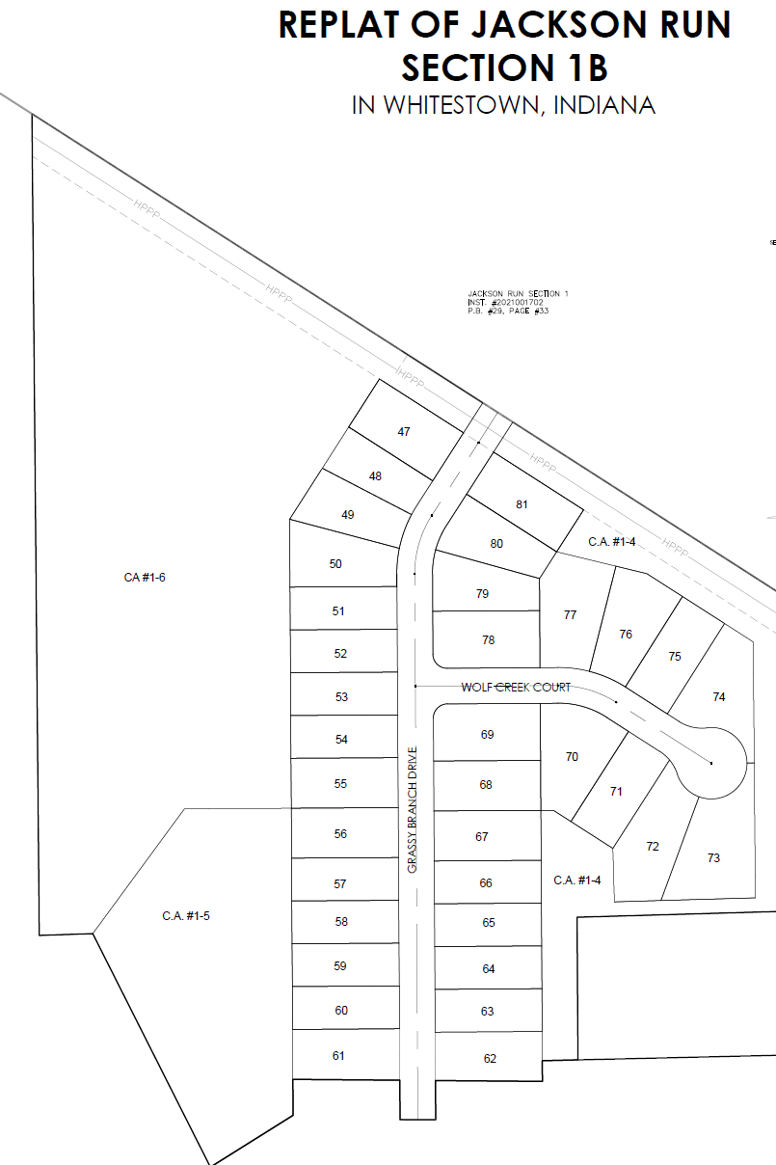

EXHIBIT A (continued)
The Real Estate / Community
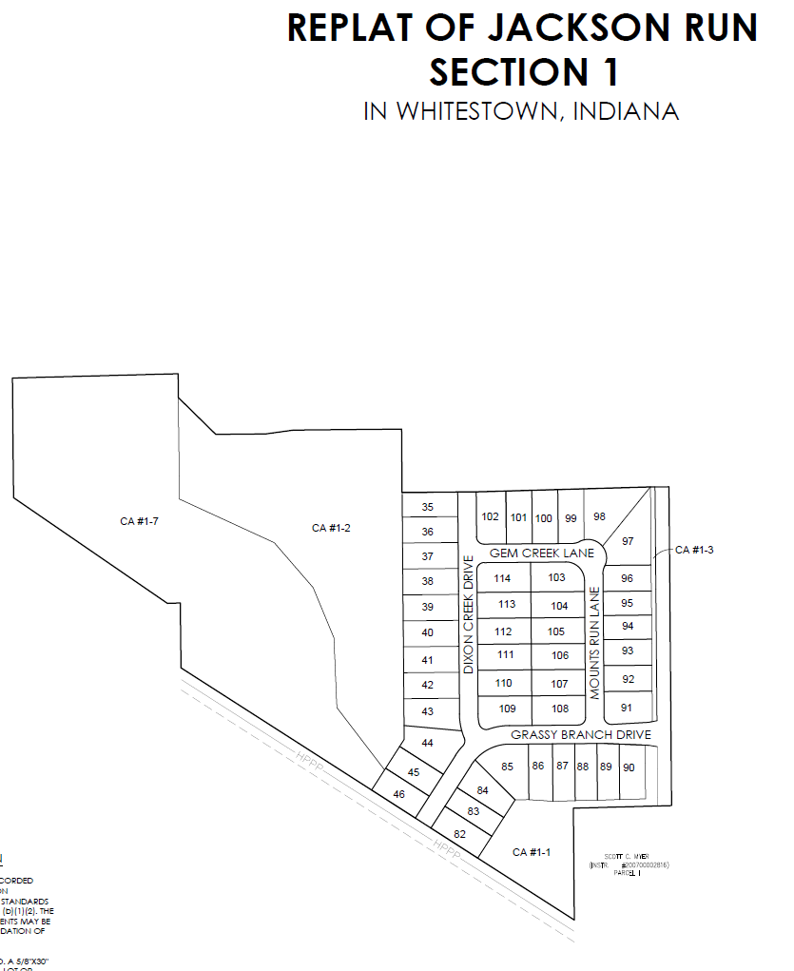

EXHIBIT A (continued)
The Real Estate / Community
JACKSON RUN NORTH
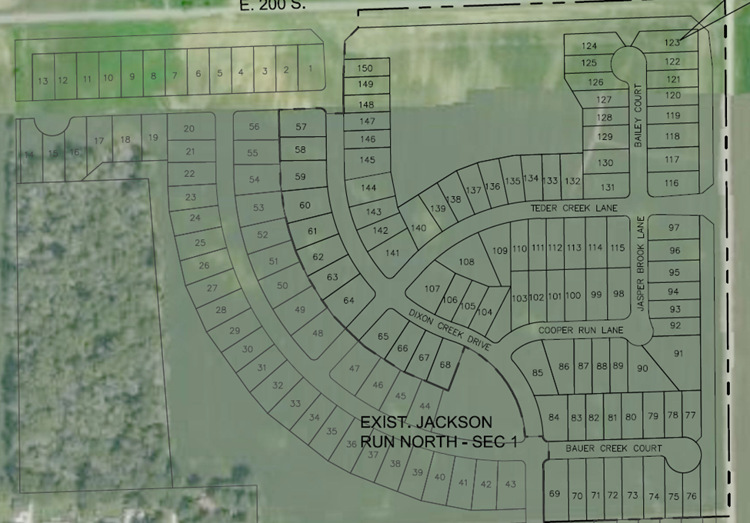

EXHIBIT B
The Park Land
